

Troubleshooting of SIP Trunking

Revision History:
Revision | Date | Author | Comments
1.0 | 2007-12-12 | Janne Magnusson | 1st version

Introduction
This document describes how to troubleshoot a SIP Trunking configuration including a ITSP, a Ingate Firewall or Ingate SIParator and a IP PBX.

It is assumed that the initial configuration has been made with the help of Ingate’s Setup Tool. If not, please first download the tool from www.ingate.com and reconfigure you Ingate unit.

Troubleshooting

Troubleshooting Outbound Calls
Symptom: When trying to make a call from an internal PBX extension to PSTN, there is no ringing signal on the PSTN phone.

Note: If you get a ringing signal on the PSTN phone, these troubleshooting steps will not help you to find the problem. Please contact your sales representative for support.

Following is an outbound traffic troubleshooting overview.

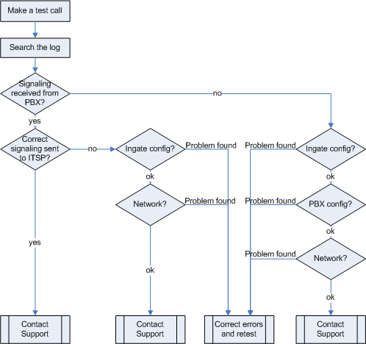

Get a log for the failing call:
First try to make a call to a PSTN number from a PBX phone and notice the behaviour on the PBX phone as well as on the PSTN phone.
Next step is to search the log on the Ingate. Log into the Ingate box and navigate to the Display Log page. Make necessary settings on this page according to the picture below. Especially make sure that you have the highlighted checkboxes in the correct state.
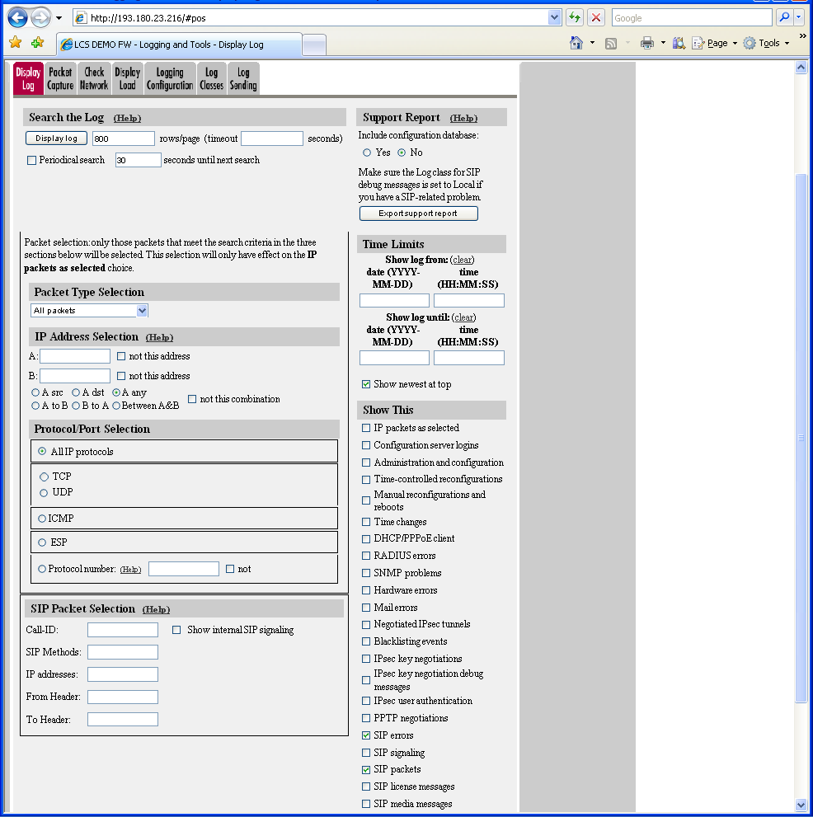

Then press “Display log” on the top of the same page.

You will now see a log of all SIP packets received and sent by the Ingate, with the newest log entry on the top.

Ensure the signaling is received from the PBX:
Localize the call initiation from the PBX by searching for “invite sip” in your browser (use Ctrl-f). You should look for the first packet coming from the PBX that starts with a “recv from <IP address of the PBX>” as you can see in the example (only the first lines of the log messages are shown here).

>>> Info: sipfw: recv from 10.100.0.40:5060 via UDP connection 12746:

INVITE sip:16037914522@10.100.0.13:5060 SIP/2.0

If you cannot find a packet like the one above, the problem is in the communication from the PBX to the Ingate. Follow these steps:

- Make sure the configuration is applied. If you have the text: ”Changes have been made to the preliminary configuration, but have not been applied” just above the tabs on the top of the page you need to apply the settings. Retest if settings applied.
- Make sure the Ingate SIP module is turned on, SIP Services – SIP Module – On. Retest if you change any setting.
- Make sure the PBX configuration is correct. Check the IP address pointing at Ingate one extra time. Retest if you change any setting.
- Make sure there is IP connectivity between the PBX and Ingate. On the Ingate use: Logging and Tools – Check Network. Contact your network administrator for assistance if needed.
If none of the steps above solves the problem, contact your sales representative for support.

Ensure that the signaling to the ITSP works:
If you find the incoming packet, you should find a similar packet leaving the Ingate just above (just after in time) the incoming packet. The first rows of the outgoing packet will look something like this:

>>> Info: sipfw: send sf (0x8422820) to 208.49.124.49:5060 via UDP connection 12748:

INVITE sip:16037914522@208.49.124.49:5060;transport=udp SIP/2.0

If you don’t see the outgoing packet, something is probably wrong with the Ingate configuration or you lack Internet connectivity:

- Make sure the Ingate is configured correctly.
- Make sure the IP connectivity between the Ingate and the ITSP is working. On the Ingate use: Logging and Tools – Check Network and ping the ITSP IP address. Contact your network administrator for assistance if needed.
- If you see a packet sent from the Ingate, verify that it was sent to the IP address provided by the ITSP. If not, correct your configuration and retest.

If none of the steps above solves the problem, contact your sales representative for support.

Troubleshooting Inbound calls
Symptom: When trying to make an inbound call to a PBX phone via the SIP Trunk, there is no ringing signal on the PBX phone.

Note: If you get a ringing signal on the PBX phone, these troubleshooting steps will not help you to find the problem. Please contact your sales representative for support.
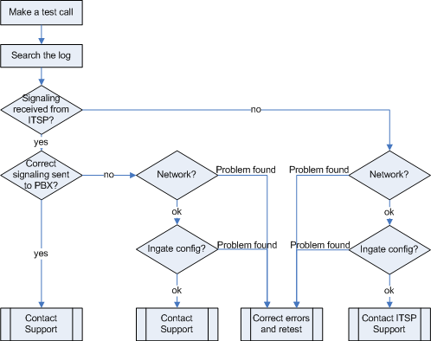
Inbound troubleshooting overview

Get a log for the failing call:
First try to make a call to a PBX phone from a PSTN phone and notice the behaviour on the PBX phone as well as on the PSTN phone.

Next step is to search the log on the Ingate. Log in to the Ingate box and navigate to the Display Log page. Make necessary settings on the logging page according to the picture below. Especially make sure that you have the highlighted checkboxes in the correct state.

Then press “Display log” on the top of the page.

You will now see a log of all SIP packets received and sent by the Ingate, with the newest log entry on the top.

Ensure that the signaling is received from the ITSP:
Localize the call initiation from the Trunking provider by searching for “invite sip” in your browser. (use Ctrl-F). You should look for the first packet coming from the ITSP system that starts with a “recv from <IP address of the ITSP>” as you can see in the example (only the first lines of the log message are shown here).

>>> Info: sipfw: recv from 208.49.124.49:5060 via UDP connection 12748:

INVITE sip:6023574058;npdi=yes@193.12.253.37:5060 SIP/2.0

If you cannot find a packet like the one above, the problem is in the communication from the ITSP to the Ingate. Follow these steps:

- Make sure the configuration is applied. If you have the text: “Changes have been made to the preliminary configuration, but have not been applied” just above the tabs on the top of the page you need to apply the settings. Retest if settings applied.
- Make sure you have IP connectivity between the Ingate and your ITSP. On the Ingate use: Logging and Tools – Check Network and ping the ITSP IP address. Contact your network administrator for assistance if needed.
- Make sure the Ingate SIP module is turned on, SIP Services – SIP Module – On. Retest if you change any setting.

If you still don’t see any packets in the log, contact your ITSP for further troubleshooting.

Ensure correct signaling to the PBX PBX:
If you find the incoming packet, you should find a similar packet leaving the Ingate just above (just after in time) the incoming packet. The first lines of the outgoing packet will look something like this:

>>> Info: sipfw: send sf (0x8419848) to 10.100.0.40:5060 via UDP connection 12746:

INVITE sip:6023574058;npdi=yes@10.100.0.40:5060;transport=udp SIP/2.0

If you don’t see the outgoing packet, something is probably wrong with the Ingate configuration or you might lack a connection to your LAN where the PBX is located:

- Ensure you have IP connectivity between PBX and the Ingate. On the Ingate use: Logging and Tools – Check Network and ping the PBX IP address. Contact your network administrator for assistance if needed.
- Make sure your Ingate is configured correctly.
- If you see the outgoing packet, make sure that it was sent to the IP address that was used by the PBX.

If the call still fails after executing the steps described above, please contact your sales representative for support.

